
LOAN INVESTMENT MEMORANDUM
Property Address
All addresses when multiple properties are involved

Transaction Overview
Loan type | Information covered
Construction | Loan amount and purpose; address; completed property description; units and square footage; LTC; repayment through permanent financing or sellout
Refinance | Loan amount; existing debt being refinanced; property description including unit configuration & square footage; junior or mezzanine financing, if applicable; repayment strategy
Note-on-Note | Castellan loan; underlying properties & its description; original lender and loan amount; current UPB; maturity; lien position; acquisition discount; use of proceeds and collateral assignment
Acquisition | Loan amount and purpose being acquisition; address; purchase price; junior/mezz loan details if any; repayment plan

Sponsorship Overview
Covers:
- Sponsor’s real estate background;
- Years of experience;
- Major completed projects;
- Number or dollar value of transactions completed;
- Relevant property-type and market experience;
- Net worth, liquidity, securities, and real estate assets;
- Credit scores and background-check results; and
- General contractor experience for construction loans, when applicable.
Sources: Sponsor biography, résumé, personal financial statement, credit report, and background report.
Automation: Use standard wording for financials and background results but populate the actual names and figures. Any bankruptcy, litigation, liens, fraud, delinquency, or other adverse finding should be flagged for review.
Submarket Overview
Covers:
- Property location and surrounding area;
- Population and income;
- Local employers and demand drivers;
- Accessibility and nearby amenities;
- Market demand relevant to the property type; and
- Information supporting the borrower’s exit plan.
Automation rules:
For a condo sellout, focus on comparable sales, pricing, buyer demand, and sales activity.
For a rental strategy, focus on rents, occupancy, vacancy, supply, and demand.
For industrial assets, focus on highway connectivity
Always include Area Median Income for multifamily/single family/condo properties.

Business Plan
Loan type | Information covered
Construction | Site acquisition; construction scope; development budget; units, square footage and amenities; construction timeline; sponsor equity; and stabilization or sellout
Refinance | Existing loan payoff and name of existing lender if available; reason for refinancing; remaining work, if any; additional time required; marketing, lease-up or sale strategy; and repayment plan
Acquisition | Property acquisition, renovation or repositioning plan, leasing assumptions, stabilization timeline, future sale or permanent refinancing, and repayment
Others | Current situation, use of Castellan’s proceeds, actions the borrower will take during the loan term, expected timeline, and ultimate exit strategy

Risks and Mitigants
Risk | Information covered
LTV Risk | Loan amount, appraised value, LTV, valuation source, comparable support, and downside protection
Sponsor Risk | Sponsor experience, prior relationship with Castellan, background results, and guarantee structure
Construction Completion Risk | Applies only to construction loans  Construction status, remaining costs, construction reserve, plan and cost review, and completion support
Environmental Risk | Environmental report provider, report status, and identified issues
Interest Rate/Return Risk | Interest rate, index, spread, floor, cap, interest reserve, and facility-rate comparison
Insurance Risk | Liability, umbrella and builder’s risk coverage; policy status; and insurance review
Automation rules:

- Include only risks that apply to the transaction.
- Confirm whether Castellan has previously worked with the sponsor under sponsorship risk.
- Use the actual recourse structure: personal guaranty, bad-boy carve-out, completion guaranty, or other support.
- Clearly state whether third-party reports are pending or completed.
- Do not state that a risk has been cleared unless the supporting report confirms it.

Loan Financials
Please see below for an overview of relevant loan metrics and other financial information about the property and transaction:
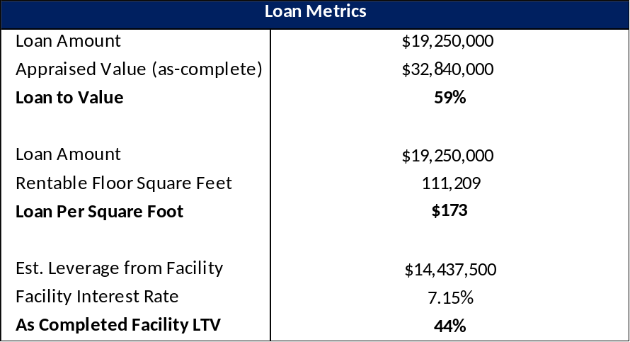
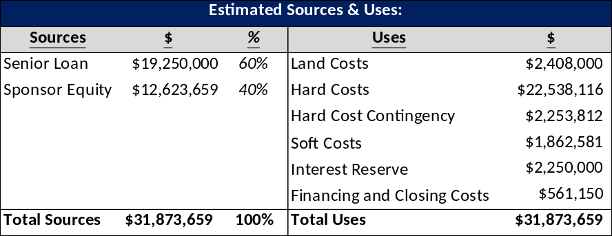
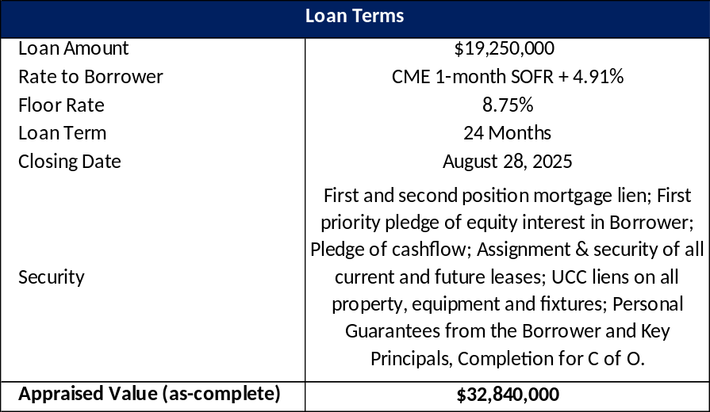
Investment Highlights
Potential highlights:
- Attractive risk-adjusted return;
- First-lien or secured position;
- Low LTV;
- Attractive loan basis compared with appraisal or sales comps;
- Experienced sponsor, developer, or contractor;
- Strong sponsor liquidity;
- Significant borrower equity;
- Protection from subordinate financing;
- Strong property location or market; and
- Ability to foreclose, sell the note, or take ownership at an attractive basis.
Automation rules:
- Include sponsor liquidity only when it exceeds $2 million.
- Include borrower equity only when it exceeds 30% of total project cost.
- Include junior or mezzanine protection only when applicable.

Pictures
Covers:
- Current property photographs;
- Renderings for construction projects; and
- Separate labels for each property.

